Stock Options Simulation: Insight into European Call Options
Group Members: Nihar Ullal, Christine Chow, Kavin Somu

Abstract
Stock options are contracts between two parties that give the buyer of the contract the right to buy or sell the underlying asset at a predetermined price within a specified period of time. There are a variety of factors that go into determining the future price of the options contract, including the stock price, the volume of the stock being traded, and other mathematical measures that this paper explores. This paper reviews existing literature on the original simulation of European options to optimize trading of options, explores a number of different models that simulate the same type of option, and then compares the proposed models to the established model. The results from the library of programs indicate simulation can be a robust tool in estimating value of options. Monte Carlo and Binomial Simulations were the simulation models tested, and we found the Binomial Simulation to provide the lowest percentage difference when compared to the Black Scholes analytical method. Simulation can provide many advantages in testing European options to see which one has the highest value.

- Background/Description of Problem
Stock options are a great way for investors to make money. A stock option gives a person the right to buy or sell a stock at a given price within a specific time period [1]. The right to buy is called an option and the right to sell is called a put. Whether or not a person makes money on a stock option contract depends on the future price of a stock. Since options often cost significantly less than purchasing an asset outright, many investors employ them to gain leverage, generate income, or safeguard their assets [3].
All options contracts contain:
- An expiration date when the contract runs its course and becomes nullified
- The strike price, or the price you committed to to buy or sell the asset
- The quantity of shares of the stock the contract covers, typically 100
- Whether the option is a call or put.
- The style of the option - American or European [3].
When an individual buys or sells an option, there is almost always a dealer on the other side of the transaction taking the inverse position [4]. The dealer is exposing themselves to unlimited losses, most of the time. When an investor writes up a put or call, they are obligated to buy or sell shares at a designated price within the contract’s timeline, even if the price is less than ideal [5].
In addition to this, the “Greeks” give the investor the measured risks associated with each option's price, which will be discussed later in the paper. Alongside these calculated risks, there exists market or systematic risk linked to broader market fluctuations. Given that a stock's price heavily influences the option's value, investors need a deep grasp of market dynamics, yet unforeseen events can still result in significant losses [8]. Furthermore, options occasionally exhibit lower liquidity compared to their underlying stocks. This reduced liquidity often results in wider bid-ask spreads, making it more challenging to execute trades at advantageous prices [8]. Options contracts are also fundamentally time-sensitive instruments. As the expiration date gets closer, the value can decrease rapidly, and it is up to the investor to time the purchase of the contract strategically to account for the time decay of the contract [8]. Lastly, options are affected by volatility risk. High volatility can result in major price changes, dramatically altering the price of the underlying contract [8]. Understanding all of these factors is key to trading options and predicting the future price.

- Main Findings
2.1 Literature Review: Black-Scholes Model
In the late 1960s, economists Fischer Black and Myron Scholes were pioneers in the field of finance, and known specifically for their work in options pricing [16]. Initially they had developed a model that removes the expected return of the security, thus producing the risk-neutral-argument [16]. They had based their work on previous scientists, but when they tried to apply their formula to the markets, they suffered heavy financial losses. It was then that they realized they had not considered risk management in their trades. In 1973, the released a paper titled “The Pricing of Options and Corporate Liabilities”, and the Black-Scholes model was born. The new formula led to a boom in options trading and provided mathematical credibility to options trading in the process [16]. The model deals primarily with European call options.
There are a number of critical assumptions the Black-Scholes model makes when trading options:
- Interest rate is known and constant through time.
- The stock follows a random walk in continuous time.
- The variance of the stock price paths follow a log-normal distribution.
- Volatility is constant.
- Stock pays no dividends.
- The option can only be exercised at expiration (i.e. it is a European option).
- There are no transaction costs.
- Fractional trading is possible. (Black Scholes Model Python 2020)
The formulas for both the put and the call is given below:
$Call = S_{0}N(d_{1})-N(d_{2})Ke^{-rT}$
$Put = N(-d_{2})K{e^{-rT}-N(-d_{1})S_{0}}_{}$
Where
$d_{1}=( ln(S/k)+(r+σ^{2}/2)*T)/(σ*√T$)
$d_{2}=$ $d_{1}$ - $(σ*√T$)
These are the base formulas in any standard Black-Scholes model [15]. The variable $d_{1}$was derived by both economists, and is roughly interpreted as the number of standard deviations the current stock price is above the strike price, adjusted for time value and volatility [16]. The variable $d_{2}$ represents the probability factor that the option will be exercised, adjusted for time value and volatility. The 5 main variables in the model are:
- S, the current stock price
- K, the strike price of the option
- r, the risk free rate
- T, the time until option expiration
- Sigma, the annualized volatility of the stock’s return [15].

For the model, if we were to hold constant all the variables except the current stock price, S, we would observe the following trend.
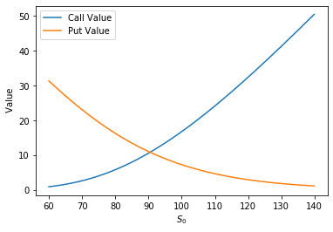
(Figure 1: S Effect on Option Value 2020)

As we can observe from Figure 1, as the value of the current stock price increases, so do the values of the calls, and as the value of the current stock price decreases, the values of the puts increase. Now let us observe what happens if we hold all variables constant except sigma.
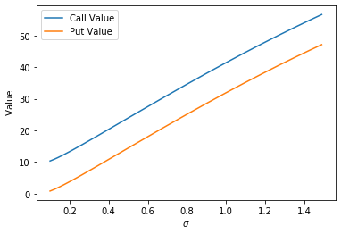
(Figure 2: Sigma Effect on Option Value 2020)

We observe in Figure 2 that both call and put options increase in value, in what surmises to be a linear fashion as shown above. But why are call options still higher in value than put options? The answer is simply because of the risk-free or interest rate, r. If we pull this parameter down to 0, the curves of both lines fall on top of each other, so we can deduce that an increase in interest rates increases the value of calls and decreases the value of puts.

2.2 Issues with Black-Scholes Model
There are a number of issues with the Black-Scholes model, namely the first one being we assume the parameter of volatility to be constant [15]. If we look at the volatility of the stock Apple (AAPL) in Figure 3 over the past 10 years, we can observe that the volatility is in no part stable.
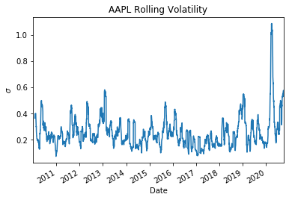
(Figure 3: AAPL Rolling Volatility 2020)
Another key issue is that the model underestimates the tail density. If we observe the Kernel Density plot in Figure 4, we see the difference between an empirical and normal distribution for Apple stock. The plot demonstrates that Black-Scholes will underestimate the value of out-of-the-money options [15].
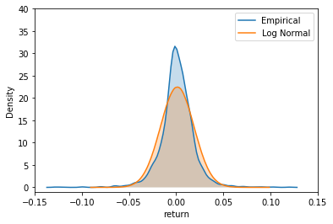
(Figure 4: KDE Empirical vs Normal 2020)
Lastly, the model assumes a constant risk-free rate of return, which will not necessarily remain constant over the period of any options contract. There are other concerns including no dividend payout, no early exercise so the model is only valid for European options, and prices only following a lognormal pattern, but the three mentioned previously are the most impactful [15]. We will now explore some of the techniques that we used to simulate options and then compare our results to the Black-Scholes model with the same parameters.

2.3 Methodology
2.3.1 Method 1: Monte Carlo Simulation - Normal Distribution
The first program we used is a Monte Carlo Simulation for calculating European call or put options. The Monte Carlo Simulation is a type of algorithm that employs iterative random sampling to estimate the probabilities of various outcomes. The simulation leverages a normal distribution to generate random samples and generates stock price paths using geometric Brownian motion. The components of the model can now be explored.
The model uses random sampling to generate future prices of the underlying stock and these samples are drawn from a normal distribution, which represent the randomness inherent in financial markets. The model calculates the expected change in the stock price over time, what is referred to as drift, and the uncertainty associated with that change, known as diffusion. The drift component accounts for the expected return adjusted for the risk-free rate and the stock’s volatility. The diffusion component captures the stochastic part of the price movement, influenced by market volatility.
Using the drift and diffusion components, the model simulates the future price of the stock at the option’s time of expiration. This is done by adjusting the current stock price based on the calculated drift and diffusion. For each simulated future price, the payoff of the option is calculated, and the payoff depends on the type of option being a call or a put. For a call option, the payoff is the positive difference between the stock price and the strike price. For a put option, the payoff is the positive difference between the strike price and the stock price.
The expected payoff is then discounted back to the present value using the risk-free interest rate. This accounts for the time value of money, ensuring that future payoffs are appropriately valued in current day’s terms. The final step involves averaging the discounted payoffs across all simulations to obtain the estimated option value. This average represents the expected value of the option under the risk-neutral measure, providing an estimate of its fair price. The risk-neutral measure is a theoretical probability measure used in financial mathematics that says all investors are indifferent to risk, meaning they do not require additional expected return for taking on risk [12].
This Monte Carlo simulation leverages the law of large numbers, and the properties of geometric Brownian motion to estimate the value of European options, incorporating both deterministic and stochastic components of price movement.

2.3.2 Method 2: Monte Carlo Simulation - Direct LogNormal
Both Method 1 and Method 2 use Monte Carlo simulations to estimate option prices, but they differ in how they generate the distribution of future asset prices. Method 1 begins by sampling from a standard normal distribution, then transforms these samples into lognormal samples by exponentiating the sum of the drift and diffusion terms derived from the standard normal distribution and the geometric Brownian motion model. In contrast, Method 2 samples directly from the lognormal distribution, with drift and diffusion components directly based on the geometric Brownian motion model. Although both methods model the future stock price $S_{t}$ as lognormally distributed, resulting in similar outcomes with a large number of replications, there are some differences. Method 2, involving direct lognormal sampling, is more straightforward and easier to implement. On the other hand, Method 1, involving normal distribution sampling and subsequent log transformation, offers more flexibility and can be adjusted for various modeling needs while still providing accurate results.

2.3.3 Method 3: Binomial Simulation
Binomial option pricing models discretize the time until expiration into a number of steps and model the evolution of the underlying asset's price over these steps. We will dive into a game that models the binomial simulation itself to explain the technique.
An investor is offered to play a game in which a fair coin is flipped n times and they get paid $1 for each head that occurs. If we flip the coin 4 times, what is the fair price for the game? Below we have created a list of 16 possible outcomes from the 4 flips ( $2^{4}$ possibilities). The results have been color coded to represent the same outcome regardless of order (HHTT = HTHT):
HHHH THHH
HHHT THHT
HHTH THTH
HHTT THTT
HTHH TTTH
HTHT TTTT
HTTH TTHT
HTTT TTHH
(Figure 5: Sample Space)
Now that we have the sample space illustrated in Figure 5, we will make a table representing the possible payoffs. The investor gets paid $1 for each heads result (H).

# of Heads | Outcomes with n Heads | Payoff | Probability | Weighted Payoff
0 | 1 | $0 | 1/16 | 0.00
1 | 4 | $1 | 4/16 | 0.25
2 | 6 | $2 | 6/16 | 0.75
3 | 4 | $3 | 4/16 | 0.75
4 | 1 | $4 | 1/16 | 0.25
(Table 1: Fair Price & Expected Payoff)
The fair price, and expected value, of this game is the sum of the Weighted Payoff column, which is $2. If the investor was offered to play the game for any price p for p<2, they would be interested in playing since on average they would make a profit of $2-$p per game played. For prices greater than 2, the investor would not be willing to play. However, if the investor were the one offering the game, they would try to find someone to pay that price as they would expect to make $p-$2 per iteration of the game [9]. What if the investor was offered to play this game in one year’s time from the current day? What price should they pay to be willing to play the game one year from now? Now that we have some context regarding how the math works, we can explain how we applied this same concept of the binomial distribution to pricing European options.
The binomial simulation uses the same principles as above. It uses a binomial tree model where it extends to n! nodes where n is the number of time steps used in the model. The beginning node starts at the strike price and has a 50% probability of either increasing by a certain amount or decreasing by a certain amount. Figure 6 illustrates a simplified binomial tree with 3 time steps, which means 8 nodes. In the example, the options price can either increase or decrease by 10% and interest rate is not taken into account for illustration purposes.. If the option value is below the strike price, then the option would be valued at $0. If the option is valued above the strike price, then the difference between the options price and the initial price would be the options value. Figure 6 details all the possibilities of options values. Table 2 displays the probabilities of different options prices, it calculates the expected value of an options value, which resulted in $7.48 [9].

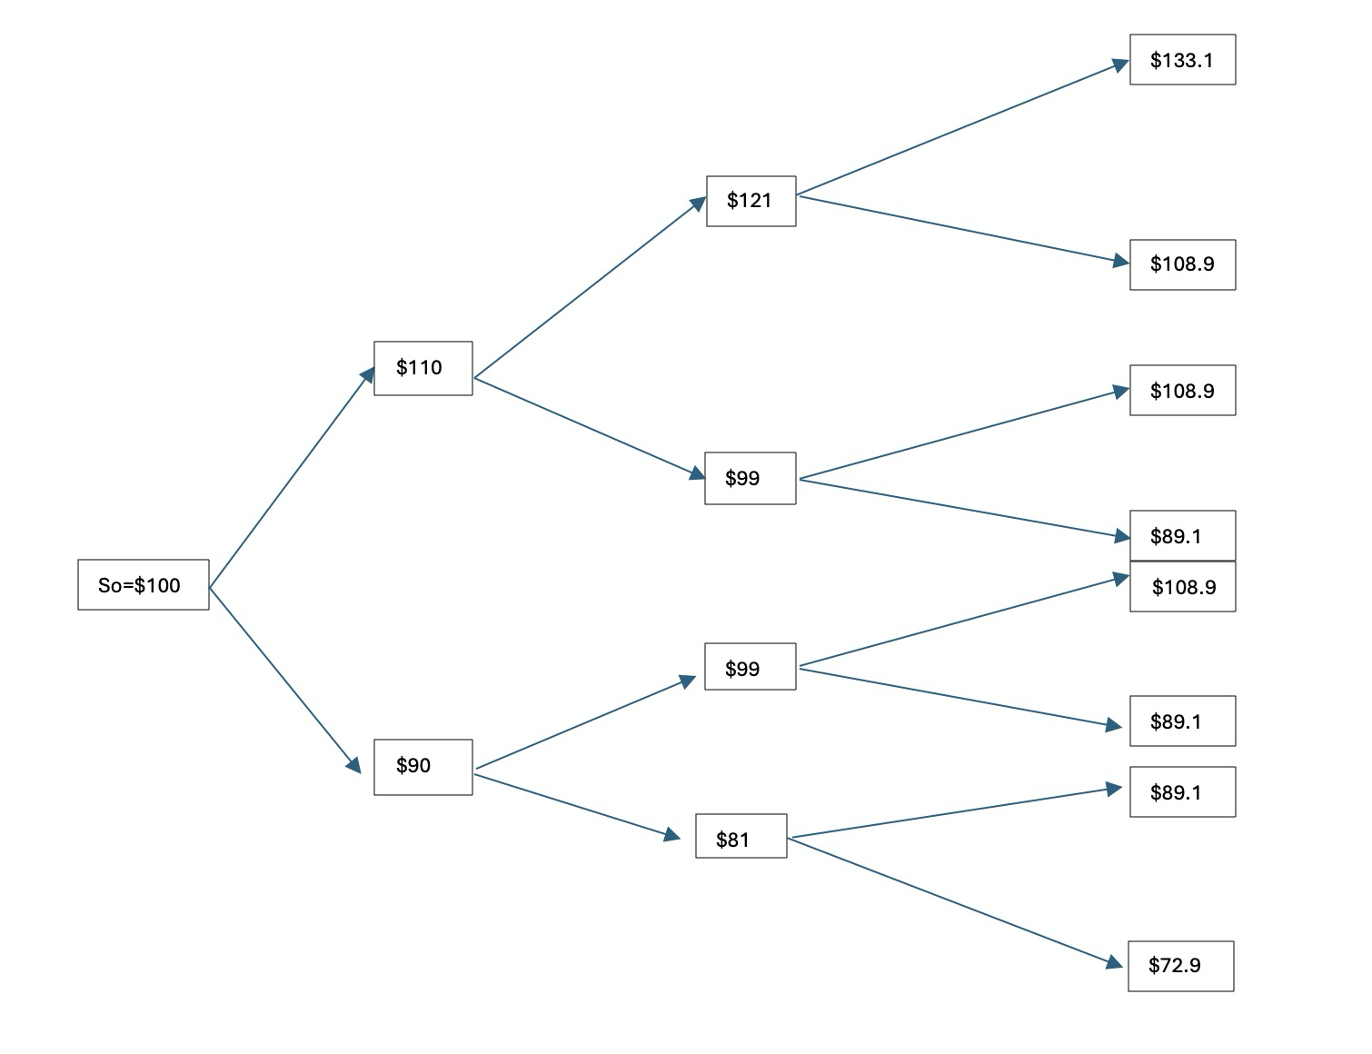
(Figure 6: Binomial Tree for Options Estimation )

Option Price | Option Valuation | Probability | Expected Value
$133.10 | $33.10 | 1/8 | $4.14
$108.90 | $8.90 | 3/8 | $3.34
<$100 | $0 | 1/2 | $0.00
 |  | Estimate | $7.48
(Table 2: Binomial Simulation Options Value Estimation)

2.4 Risk Calculation
2.4.1 The Greeks
A common method of evaluating different mathematical models for option pricing estimates is “The Greeks”. These calculated risks actually help to mitigate the risk of options, especially compared to other less quantifiable investments [1]. The risks are associated with the following Greek symbols:

- Delta: measures price movement in the option with a $1 change in stock price
  - $δ: \frac{∂C}{∂S}=N(d_{1}), \frac{∂P}{∂S}=-N(d_{1})$ [12]
- Gamma: measures the rate of change in delta with a $1 change in stock price
  - $Ɣ: \frac{∂^{2}C}{∂S^{2}}=\frac{∂^{2}P}{∂S^{2}}=\frac{N'(d_{1})}{S * (σ * √T)}$ [12]
- Theta: also known as the “time decay”, indicates how much value an option will lose with one day passing.
  - $θ :\frac{∂C}{∂T}=-\frac{S * N'(d_{1}) * σ }{2√T}-rKe^{-rT}N(d_{2}) ,\frac{∂P}{∂T}=-\frac{S * N'(d_{1}) * σ }{2√T}+rKe^{-rT}N(-d_{2})$[12]
- Vega: the amount by which the price of the option will change based on a 1-point change in implied volatility
  - $v : \frac{∂C}{∂σ}=\frac{∂P}{∂σ}=S * √T *N'(d_{1})$[12]
- Rho: the amount by which the price of the option will change based on a 1% change in interest rate [1].
  - $⍴ :\frac{∂C}{∂r}= KTe^{-rt}N(d_{2}), \frac{∂P}{∂r}=-KTe^{-rt}N(-d_{2})$ [12]

Together, these calculations help investors gauge the health of their portfolio by providing critical signals and indicators for reassessing their choices. Investors seeking stable, low-risk investments versus those pursuing risky, high-reward investments will have different considerations regarding "The Greeks."
For example, delta helps investors predict the probability of the option being profitable. A delta of 0.7 means that the option has a 70% chance of being “in-the-money” at expiration[19]. "In-the-money" means that the strike price is lower than the current market stock price, allowing the investor to buy it below market price. Therefore, a higher delta would be more useful for riskier high-risk, high-reward investments, while a lower delta is better for low-risk, lower-reward investments [19].
Gamma is the second derivative of delta, which is another way of saying that it measures the rate of change and stability of delta. Gamma is an indicator of an option’s stability and predictability; a higher gamma will indicate more volatile swings, while a lower gamma will indicate more stability [19].
Theta is the change in option price relative to time and is usually negative, representing the loss in an option’s value over a period of time. Investors generally prefer a smaller (less negative) theta, as it means less loss due to time decay [19].
Vega represents the fluctuation in option price in relation to volatility. Investors anticipating higher volatility would want a higher vega, while those expecting lower volatility would prefer a lower vega [19].
The last major Greek is rho, which represents the change in stock price relative to interest rate. A higher rho is preferable when interest rates are expected to rise, while a lower rho is ideal when rates are falling [19].

2.5 Fundamental Results
2.5.1 European Option
After running the three different models shown above, the following results were obtained. The methods discussed above will be compared to Black Scholes since this is the industry standard analytical method for calculating options pricing. Since Binomial simulation uses number of nodes instead of number of replications, the comparison with Black Scholes will have its own chart and graph.
Table 3 shows the price calculations using the different methods. The first observation is that Monte Carlo produces the same options value when generating random variables using normal variables and lognormal variables. The initial hypothesis was that the results would be different. However, after closely examining the code, the formulas use different approaches but mathematically deliver the same results. For the Normal MC method, normal variables are generated and then exponentiated when $S_{T}$ is calculated. Whereas the Lognormal directly generates lognormal variables and then uses that in the $S_{T}$ calculations. Therefore, the options values were the same in both simulations [23].
The next observation is that as the number of replications goes to infinity, the options values get closer to the Black Scholes estimation. Figure 7 showcases this where the absolute percent change gets closer to 0 as the number of replications goes up. This follows the principle that as more simulations are run, the variance in results decreases. As the computing power was not an issue when generating these simulations, it can be concluded that 1,000,000 trials would be the suggested number of trials in generating the most accurate options value when estimating through simulation.

Replications | Normal MC | Lognormal MC | Black Scholes (BS) | % Change MC & BS
1 | 7.8325 | 7.8325 | 8.0214 | -2.41%
100 | 7.7588 | 7.7588 | 8.0214 | -3.38%
1000 | 7.8499 | 7.8499 | 8.0214 | -2.18%
10000 | 8.1451 | 8.1451 | 8.0214 | 1.52%
100000 | 8.0525 | 8.0525 | 8.0214 | 0.39%
1000000 | 8.0238 | 8.0238 | 8.0214 | 0.03%
(Table 3: Monte Carlo Simulation vs Black Scholes Model Results)
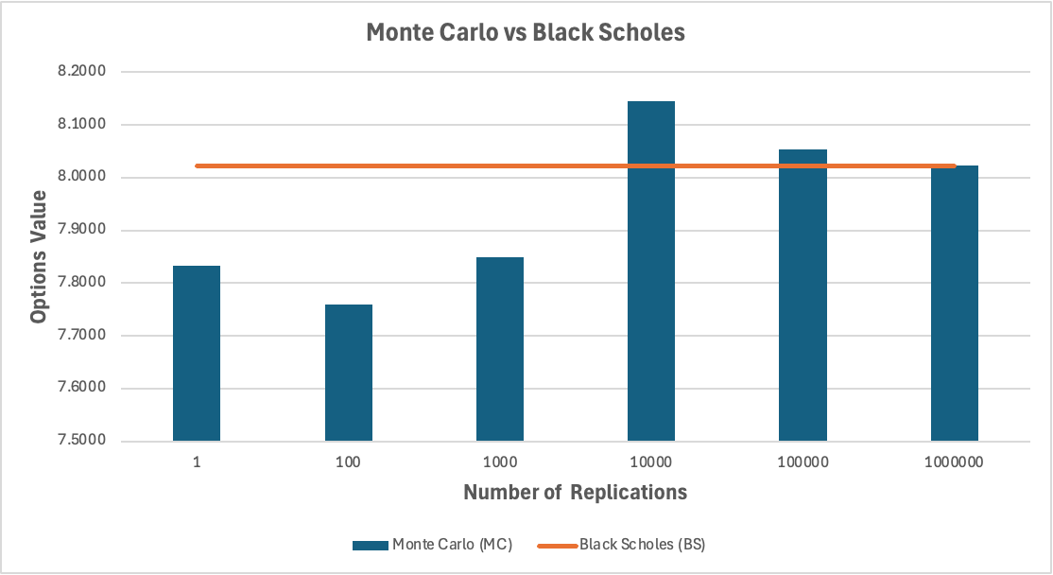
(Figure 7: Monte Carlo Simulation vs Black Scholes Graph )

Now Binomial Simulation will be compared to Black Scholes. Instead of a number of replications, this simulation uses nodes. Similarly, as the number of nodes increases, the binomial simulation gets closer to the Black Scholes value. From the simulation, 50 nodes (Table 4) is sufficient in generating a value with a very low percentage change from the Black Scholes value.

Nodes | Binomial | Black Scholes | % Change
1 | 9.4156 | 8.0214 | 14.81%
50 | 8.0143 | 8.0214 | -0.09%
100 | 8.0262 | 8.0214 | 0.06%
500 | 8.0232 | 8.0214 | 0.02%
1000 | 8.0211 | 8.0214 | 0.00%
(Table 4: Binomial Simulation vs Black Scholes Model Results)
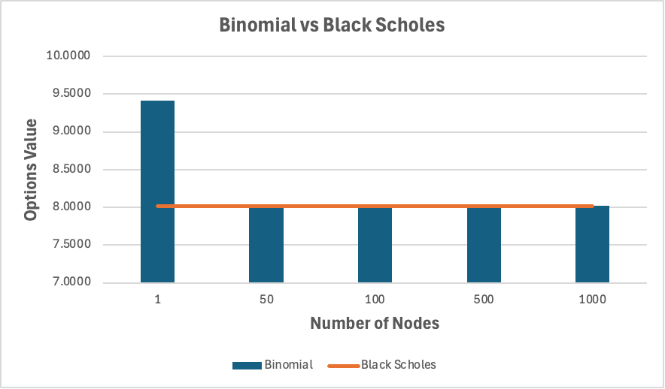
(Figure 8: Binomial Simulation vs Black Scholes Graph )
When comparing all of the models’ results, the binomial model provided the most precise result when compared to the Black-Scholes, with a 0.00% error, while the Monte Carlo came in a very close second with a 0.03% error.
2.5.2 Greek Results
Lastly, the final section of the programming library will be discussed, detailing the analytical derivation of Greek calculations. Table 5 displays the results of the Greek calculations. The parameters for greek calculations were defined above and were the same parameters used in estimating options values.
Initially, the “Greeks” for option calls will be examined. The first Greek letter calculated was delta at 0.5422. This indicates the option is “at-the money.” “At the money” indicates that exercising an option would neither gain or lose money. The gamma value calculated is 0.0198, indicating that if the options value were to go up by $1, then the delta would increase to .562 [24]. Theta was calculated as -0.0172, which indicates that the options value will decrease by that amount everyday if all else stays the same. Assuming we take the Black Scholes estimation as the options value (8.0214) then after 10 days, the option will be valued at 7.8494 10 days later. Additionally Vega is calculated as 0.3967, which indicates that the price of the option goes up by that much if the volatility goes up by 1% [25]. A key concept to note here is that the more volatile an option is, the higher the chance the option value will spike up, which means higher volatility increases the value of an option. If the volatility went from 20% to 21%, the option price would go up to 8.4181. Lastly, Rho is calculated to be .4620, meaning a call option value will increase by that amount if the interest rate increases by 1%. Therefore if the interest rate went from 5% to 6% then the call option value would be 8.4834.
Finally, the Greeks for option puts will be examined (Table 5). Gamma and Vega will have the same values as the options calls because gamma is primarily concerned with the change in delta and vega is only concerned with the change in volatility. Therefore the type of option is not relevant for these calculations. For put options, negative greek values indicate an increase in option value as one will be able to sell a put option for a wider margin. Delta was calculated to be -0.4578 indicating this is the amount a put option’s value will increase by 0.4578 for every $1 the put options price decreases. For theta, interestingly enough the put option decreases by a smaller quantity as time moves forward. Rho indicates that a put option will increase 0.5368 if the interest rate decreases by 1%.

Greeks | Call Options | Put Options
Delta | 0.5422 | -0.4578
Gamma | 0.0198 | 0.0198
Theta | -0.0172 | -0.0035
Vega | 0.3967 | 0.3967
Rho | 0.4620 | -0.5368
(Table 5: Greeks Calculations)

2.5.3 Other Proposed Problems to Solve
The Black Scholes makes an assumption that volatility remains constant during the lifespan of an option, which in reality is not true. Future studies can look into how to incorporate volatility as a random process in the model and use that input towards estimating options values. This will capture the true nature of an option’s volatility. Challenges in volatility make it more difficult to analytically estimate exotic options such as Asian options, whose valuation is dependent on the average price over time. Black Scholes assumes a lognormal distribution and averaging the lognormal variables no longer generates a lognormal distribution, therefore making it difficult to extend this model to Asian options. Future analysis into Asian options can look into using Taylor Series expansion to mitigate the complexities derived from volatility and non-lognormal distributions[26].
3. Conclusion
Binomial Simulation provided an estimation closest to Black-Scholes model, therefore this simulation would be the best for reducing variability. While the Black-Scholes can give a calculation at a specific point in time, simulation allows one to test many different scenarios to see what a reasonable strike price would be for an option. In addition to adjusting strike prices, time to maturity, and other variables, the Greeks can be a useful tool for providing statistical measures for options at different strike prices. The function developed in this project can be applied in a real world setting where one has to choose an option to buy. By running the code to estimate the value and the greek statistics associated with various options, one would be able to determine the most lucrative option to purchase. Future studies can incorporate volatility into simulation models to give a more realistic prediction for options. In addition, researchers can develop models for exotic options, thereby giving investors a broader choice in which options they would like to put money into.

Works Cited

[1] Downey, L. (2024, May 15). Essential Options Trading Guide: How to get started. Investopedia. https://www.investopedia.com/options-basics-tutorial-4583012
[2] Chen, J. (2022, April 21). Vanilla option: Definition, types of option, features and example. Investopedia. https://www.investopedia.com/terms/v/vanillaoption.asp#:~:text=If%20a%20vanilla%20option%20is,net%20cost%20or%20increase%20leverage.
[3] Money, F. S. (2023, October 11). What are options, and how do they work?. Fidelity. https://www.fidelity.com/learning-center/smart-money/what-are-options
[4] The implied order book. (n.d.). https://squeezemetrics.com/download/The_Implied_Order_Book.pdf
[5] Yochim, D. (2017, May 26). Risks and benefits of trading options. NerdWallet. https://www.nerdwallet.com/article/investing/options-trading-risks-benefits#:~:text=1%20Can%20expose%20an%20investor%20to%20unlimited%20losses,3%20Margin%20requirements%20can%20run%20up%20trading%20costs
[6] Peterson, N. (2022, January 23). Common pitfalls for new options traders. Schwab Brokerage. https://www.schwab.com/learn/story/common-pitfalls-new-options-traders
[7] Seth, S. (2022, March 13). Circumventing the limitations of Black-Scholes. Investopedia. https://www.investopedia.com/articles/active-trading/041015/how-circumvent-limitations-blackscholes-model.asp
[8] Reviewfx, B. (2024, January 29). Risks in options trading: A comprehensive guide. Forex Listing. https://www.brokerreviewfx.com/risks-in-options-trading-a-comprehensive-guide/#:~:text=Types%20of%20Risks%20in%20Options%20Trading%201%201.,Risk%20Options%20are%20prone%20to%20volatility%20risk.%20
[9] John. (2020, December 21). Binomial option pricing pricing model with python. CodeArmo. https://www.codearmo.com/python-tutorial/options-trading-binomial-pricing-model
[10] John. (2020b, December 26). Option greeks by Analytic & Numerical Methods with python. CodeArmo. https://www.codearmo.com/python-tutorial/options-trading-greeks-black-scholes
[11] Stringham, T. C. (2021, February 9). Option pricing: Black-scholes v binomial v Monte Carlo simulation. LinkedIn. https://www.linkedin.com/pulse/option-pricing-black-scholes-v-binomial-monte-carlo-stringham
[12] Calculating the greeks with finite difference and Monte Carlo methods in C++. QuantStart. (n.d.). https://www.quantstart.com/articles/Calculating-the-Greeks-with-Finite-Difference-and-Monte-Carlo-Methods-in-C/
[13] Scott, G. (n.d.). What is risk neutral? definition, reasons, and vs. risk averse. Investopedia. https://www.investopedia.com/terms/r/riskneutral.asp
[14] Menghani, R. (2023, July 8). Computing option price and greeks using Monte Carlo Simulation. Medium. https://medium.com/@rmenghani21/computing-option-price-and-greeks-using-monte-carlo-simulation-21a3a24d11ba
[15] Dains, E. (2021, May 1). Monte Carlo Methods for option pricing and greeks. Optionally Bayes. https://eadains.github.io/OptionallyBayesHugo/posts/option_pricing/
[16] Black Scholes Model Python. CodeArmo. (2020, December 20). https://www.codearmo.com/python-tutorial/options-trading-black-scholes-model/
[17] Understanding the black-scholes model. Morpher. (n.d.). https://www.morpher.com/blog/black-scholes-model
[18] Gibiansky, A. (n.d.). Pricing stock options via the binomial model. https://andrew.gibiansky.com/downloads/pdf/Pricing Stock Options via the Binomial Model.pdf
[19] Summa, J. (n.d.). Option greeks: The 4 factors to measure risk. Investopedia. https://www.investopedia.com/trading/getting-to-know-the-greeks/#:~:text=This%20generally%20means%20traders%20can,strategies%20with%20high%20win%20rates
[20] John. (2020a, October 8). Pricing options by Monte Carlo simulation with python. CodeArmo. https://www.codearmo.com/blog/pricing-options-monte-carlo-simulation-python
[21] Option pricing using simulation. (n.d.). https://scribbler.live/2023/05/04/Monte-Carlo-Simulation-for-Option-Pricing.html
[22] Goldsman, D. (n.d.). M7l19 Brownian motion. Google Docs. https://docs.google.com/document/d/1o5cJt9nsl0WvicUykomYprmU0hIBxdvWfYY0Aj0C7QE/edit#heading=h.cth82rwwao62
[23] Sigman, K. (2006). 1 geometric Brownian motion. https://www.columbia.edu/~ks20/FE-Notes/4700-07-Notes-GBM.pdf
[24] Hall, M. (2023, September 30). Using the “greeks” to understand options. Investopedia. https://www.investopedia.com/trading/using-the-greeks-to-understand-options/
[25] Chen, J. (2020, December 28). What is Vega? definition in options, basics, and example. Investopedia. https://www.investopedia.com/terms/v/vega.asp
[26] Lin, C.-G., & Chang, C.-C. (2019, March 22). Approximate analytic solution for Asian options with Stochastic volatility. The North American Journal of Economics and Finance. https://www.sciencedirect.com/science/article/abs/pii/S1062940818305734

